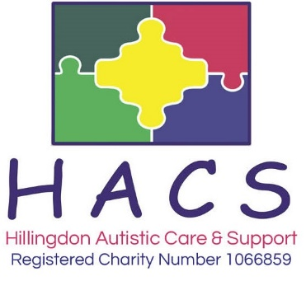**Workshop Booking form**

I would like to request a place on the following workshop:

|  |  |
| --- | --- |
| **Workshop Title** |  |
| **Workshop Date & Time** |  |

**Details of person attending:**

|  |  |
| --- | --- |
| **Name** |  |
| **Contact Number** |  |
| **Address** | (If you are a professional please use the address of your organisation) |
| **Post code** |  |
| **Email** |  |
| **Circle your answer** | **I would like to be added to your mailing list: Yes / No** |
| **Special Requirements** |  |

**If you require an invoice, please complete the following to who this should be sent**

|  |  |
| --- | --- |
| **Name** | **Email** |

**Please tick your chosen payment method**

|  |  |
| --- | --- |
| **BACS payment**  Sort Code 20-73-53 Account No. 63532836 Account Name: Hillingdon Autistic Care and Support.  Please quote your surname and workshop title as payment reference if you do not require an invoice | **Cheques**  Payable to Hillingdon Autistic Care & Support  Cheques posted are at owner’s risk  **Cash**  Deliver to: HACS, Dudley Place, Off Pinkwell Lane, Hayes, Middx UB3 1PB  Cash posted is at owner’s risk |

**For further enquiries please telephone:** 0208 606 6780

**Please email this form to** [catherine@hacs.org.uk](mailto:catherine@hacs.org.uk)

**Or post this form to:** Hillingdon Autistic Care and Support, Dudley Place, Hayes, UB3 1PB

